4th International Conference on Digital Transformation and Applications (ICDXA 2025)

Normal and Abnormal ECG Signal Detection using Convolutional Neural Network on Modified MIT-BIH Dataset

Anonymise paper: Leave space for First Authorª, Second Author^{b}, Third Author^{a,b,}*

ª Leave space for affiliation, address, city and postcode, country
^{b} Leave space for affiliation, address, city and postcode, country

Abstract
This study investigates the use of a one-dimensional Convolutional Neural Network (1D CNN) for classifying electrocardiogram (ECG) signals into normal and abnormal categories based on the PQRST-wave morphology. It is the standardized representation of a typical human heartbeat. The dataset employed is a modified version of the MIT-BIH Arrhythmia Database, which then pre-processed into single-heartbeat segments of uniform length. While expert cardiologists remain the gold standard in detecting subtle cardiac anomalies, traditional diagnostic approaches face challenges in scalability and accessibility. The proposed 1D CNN model autonomously extracts temporal features without manual engineering, offering a scalable alternative for preliminary screening. The model achieved a high classification accuracy of 99%, with precision, recall, and F1-score reaching 0.99 (weighted average). For normal heartbeats, the model attained a precision of 0.98 and recall of 1.00, while for abnormal beats it achieved perfect precision (1.00) and a recall of 0.96. These results highlight the model’s robustness in binary classification tasks. Again, although not a substitute for expert evaluation, this approach holds promise for deployment in resource-limited settings or wearable devices for real-time arrhythmia detection, with final diagnoses remaining under clinical oversight.
xxx leave space
xxx leave space
xxx leave space
xxx leave space

Keywords: ECG; Arrhythmia; 1D CNN; Signal Classification; Cardiac Detection

1. Introduction
Cardiovascular diseases remain the primary cause of global mortality, with cardiac arrhythmia and or irregularities in the heartbeat, serving as vital indicators of heart dysfunction be it benign or may it lead to more severe outcome [1,2]. Out of those severe outcome, is stroke the most prevalent and commonly appeared one, where every seconds count a second too late may lead to brain dysfunction or even death, making timely detection essential [3,12]. Electrocardiogram (ECG) analysis in general is widely regarded as a fast, non-invasive, and cost-effective method for arrhythmia detection [2,15]. However, manual ECG interpretation depends heavily on the expertise of trained cardiologists and is subject to variability, especially in the presence of signal noise or ambiguous heartbeat patterns [3,13].
In places where access to specialized cardiology services is limited or unavailable or even very costly, the need for consistent and automated screening tools becomes critical. Artificial Intelligence (AI), specifically Deep Learning (DL) model, has shown significant promise in biomedical signal classification, enabling the development of Computer-Aided Diagnosis (CAD) systems capable of supporting clinical decision-making in low-resource environments [5,6,14]. Unlike traditional rule-based systems, DL methods such as Convolutional Neural Networks (CNN) can learn distinct features directly from raw ECG signals, allowing for efficient detection without extensive pre-processing or expert feature engineering [2,4].
This research investigates the application of a 1D Convolutional Neural Network (1D CNN) on a self-modified MIT-BIH dataset as in cutting multiple heartbeats in a single data to just the distinct PQRST wave form, designed to classify single heartbeats as either normal or abnormal [1]. Rather than seeking to replicate the specialized judgment of experienced cardiologists, the proposed model aims to provide rapid preliminary assessment, supporting early intervention and prioritization of high-risk patients in cases where the amount of cardiologist is significantly less than patients needing monitoring. The approach emphasizes low computational complexity to ensure feasibility for deployment in resource-constrained environments such as mobile application or IoTs product where immediate specialist evaluation is impractical.
By integrating AI-based classification into initial screening workflows, this research contributes to the broad goal of expanding access to cardiac care and monitoring, especially in underserved regions or regions where such access albeit available are costly. The work is situated within applied research in Artificial Intelligence and Biomedical Engineering, with specific relevance to scalable and accessible arrhythmia detection.

2. Literature Review
Literature Review builds the theoretical foundation by examining the concepts of Electrocardiogram (ECG), cardiac arrhythmia, Deep Learning fundamentals, 1D Convolutional Neural Network architectures, and the MIT-BIH Arrhythmia dataset. This chapter synthesizes current knowledge to identify gaps and opportunities that this research addresses.

2.1 Electrocardiogram
Electrocardiogram (ECG) is a biological signal that records the electrical activity of the heart through skin electrodes [12]. The ECG signal consists of three main waves, as shown in Figure 1, namely the P wave, which represents atrial depolarization, the QRS wave, which represents ventricular depolarization, and the T wave, which represents ventricular repolarization. This ECG signal normally has a frequency range of about 0.05 Hz - 1000 Hz and an electrical range of about 1 mV - 10 mV [13].
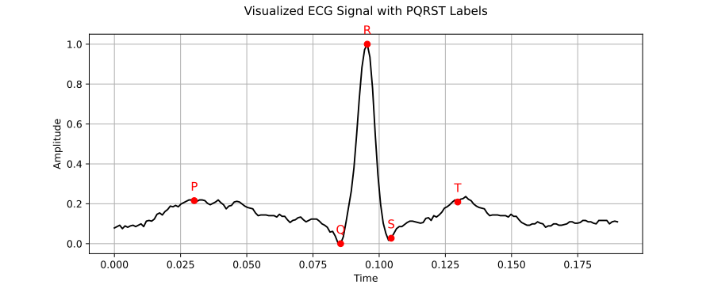
Fig. 1. Structure of a Electrocardiogram Signal
During recording, various unwanted signals or noise may combine with the actual ECG signal. This noise must be removed to avoid analysis problems that can lead to misdiagnosis. Since noise has characteristic frequency patterns, filtering specific frequency ranges helps isolate the genuine ECG signal from contamination. The ability to obtain clean, interpretable ECG signals forms a critical foundation for both traditional clinical interpretation and automated analysis approaches.

2.2 Denoising in ECG signal processing
In biomedical signal processing, particularly Electrocardiogram (ECG) signals, noise presents a significant challenge that can compromise analysis accuracy. These disturbances originate from various sources including baseline wander, powerline interference, patient movement, and muscle activity. Consequently, effective denoising represents an essential preprocessing step before applying CNN models to ECG data. Within this research context, denoising employs structural and segmentative approaches rather than explicit mathematical filtering methods. The ECG data, sourced from the MIT-BIH Arrhythmia Database with expert annotations, undergoes processes such as normal signal length trimming, label repositioning, and shifting that indirectly eliminate noise-contaminated signal portions, particularly in pre- and post-detection regions as illustrated in Figure 2.

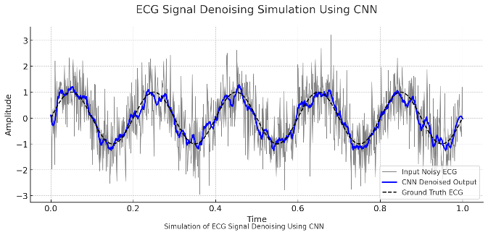
Fig. 2. ECG Denoising
This approach exemplifies implicit noise reduction through selective segmentation and data structure normalization rather than traditional filtering algorithms. Research has demonstrated this method's effectiveness because deep learning models, particularly hybrid CNN-LSTM architectures, exhibit high sensitivity to both structural and numerical variations in input data [14]. Therefore, while not implementing conventional denoising techniques, this research effectively applies adaptive denoising principles through annotation-guided segmentation and selective inclusion strategies that enhance model robustness against noise-induced signal variations.

2.3 Arrhythmia Detection, Abnormal Signals, and Signal Variability

Arrhythmia represents an abnormal cardiac rhythm condition with potentially life-threatening consequences, manifesting in various forms including ventricular tachycardia (VT) shown in Figure 3, ventricular fibrillation (VF) in Figure 4, and atrial fibrillation (AF) in Figure 5. These conditions cause heart rates to become excessively fast, abnormally slow, or irregularly patterned. Arrhythmias occur when the electrical impulses regulating heartbeats malfunction, resulting in chaotic cardiac electrical activity [15]. According to the American Heart Association (AHA), arrhythmias constitute a primary cause of various cardiovascular complications, making early ECG-based detection a crucial component in preventing heart failure and stroke [16].
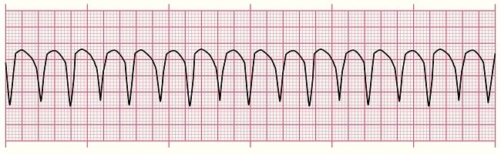
Fig. 3. Ventricular Tachycardia (VT)
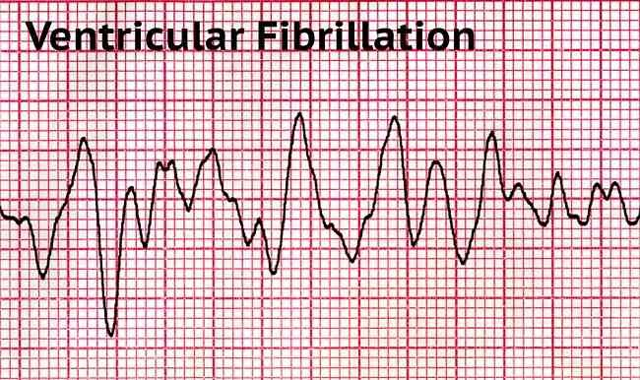
Fig. 4. Ventricular Fibrillation (VF)
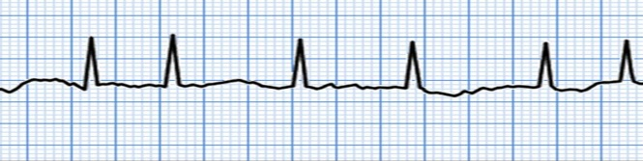
Fig. 5. Atrial Fibrillation (AF)

For ECG signal classification purposes in this research, all abnormal heartbeat manifestations receive categorization as class "1" (arrhythmia), while normal heartbeats are designated as class "0". This binary classification approach aligns with the machine learning methodology employed, optimizing modelling efficiency and analytical clarity. Consolidating diverse heartbeat abnormalities under a single arrhythmia label proves sufficiently representative during initial classification stages, particularly when the model primarily focuses on detecting abnormality presence rather than differentiating specific abnormality types [14]. This approach supports the intended use of the system as a screening tool rather than a comprehensive diagnostic platform.

2.4 Heart Rate Variability
Heart Rate Variability (HRV) measures the time fluctuations between consecutive heartbeats, typically calculated from RR intervals within ECG signals. HRV reflects the balance between sympathetic and parasympathetic nervous system activity and serves as an important indicator of cardiovascular health and physiological stress levels [17]. Analysis of HRV typically employs three complementary approaches: time domain measures (including SDNN and RMSSD), frequency domain analysis (examining LF, HF, and LF/HF ratios), and non-linear domain methods (such as Poincaré plots and entropy calculations).
Machine learning research frequently utilizes these HRV features to distinguish between normal and abnormal cardiac conditions [18]. Characteristically, reduced HRV metrics indicate abnormal conditions such as arrhythmias or cardiac stress, whereas elevated HRV values suggest a healthy, adaptable autonomic system. Within this research context, HRV serves as a discriminative signal characteristic that functions as either an input parameter for CNN or LSTM models or as an indicator of deteriorating cardiac rhythm quality. Understanding HRV patterns enhances the model's ability to detect subtle abnormalities that might otherwise escape detection through basic waveform analysis alone.

2.5 MIT-BIH Arrhythmia Dataset
The MIT-BIH Arrhythmia Database is a widely used benchmark for ECG signal analysis [9]. It includes 48 two-lead ECG recordings, each 30 minutes long, collected from 47 subjects at a 360 Hz sampling rate. Over 100,000 beats are manually labeled into more than 15 categories, including normal, ventricular, and atrial premature beats [1], [2], [5]. Each recording includes signal data, annotation labels, and sample indices, structured according to AAMI standards [19].
This study uses a simplified version from Kaggle [20], which consolidates heartbeats into two classes: Normal (0) and Abnormal (1). This format, along with expert annotations, digital accessibility, and patient metadata, makes the dataset highly suitable for training machine learning models with broad generalization capabilities [7].

2.6 Data Preparation
T Data preparation commences with exploratory data analysis (EDA) to comprehensively understand data distribution patterns, identify missing values, and detect outliers. Research by Zahid et al. [22] demonstrates that outliers in ECG data can significantly impact detection model performance, particularly regarding extreme signal values resulting from hardware interference or environmental noise. Consequently, the preparation process incorporates Z-score normalization techniques for effective data cleaning. Calculating Z-scores follows Eq.1.

$z=\frac{x-μ}{σ}$
(1)
Where x represents the signal amplitude value, μ denotes the population mean, and σ indicates the standard deviation. Values where Z>3 or Z<−3 are identified as outliers and subsequently removed from the dataset. To address class imbalance between Normal and Abnormal categories, the methodology implements resampling techniques or stratified data selection methods. Alinsaif [23] notes that unbalanced class distribution typically biases models toward majority classes, necessitating balancing procedures before training commences.
Furthermore, arrhythmia signal diversity undergoes validation through K-Means Clustering analysis, ensuring that abnormal class data encompasses a broad spectrum of physiological variations. The objective function guiding K-Means clustering is expressed in Eq.2.
$$\arg{\min_{\{C_{1},C_{2},…,C_{k}\}}\left\{\sum_{i=1}^{k}{\sum_{x∈C_{i}}{\left.||x-μ_{i}\right.{||}^{2}}}\right\}}$$
(2)
Where Ci represents the i-th cluster and μ denotes its centroid. This formula seeks to minimize the total squared distance between each data point and its assigned cluster centroid. Specifically, x represents individual data points while ∥x−μi ∥ indicates squared Euclidean distance. Lower function values indicate more compact, well-defined clusters, confirming the algorithm's success in identifying natural data structures. Finally, dimensionality reduction through Principal Component Analysis (PCA) extracts essential components and minimizes dimensional redundancy, as shown in Eq.3.
$$T = X ⋅W$$
(3)
where T represents the transformation result, X indicates the input data matrix, and W denotes X's covariance eigenvector matrix. Research by Eleyan and Alboghbaish [24] confirms PCA's effectiveness in enhancing ECG model training efficiency while preserving critical signal information.

2.7 CNN and Conv-1D
A Convolutional Neural Network (CNN) is a deep learning model that uses convolution operations to detect spatial patterns in data [30]. It is widely used in signal classification, pattern recognition, and medical image analysis due to its efficiency in extracting complex features with fewer parameters than traditional neural networks [30]. CNNs are categorized by input type:
1-D CNN for time-series data like ECG signals and speech.
2-D CNN for image data.
3-D CNN for video or 3D medical scans.
This research applies 1-D CNN to process ECG signals, where Conv1D layers slide kernels across time to extract features like QRS complexes, P waves, and T waves. Parameters such as kernel size and stride are tuned to match signal characteristics. Prior studies confirm that Conv1D is effective for ECG feature extraction [35,36].

2.8 Auto Encoder
Autoencoder represents a specialized artificial neural network architecture designed to perform data compression (encoding) followed by subsequent reconstruction (decoding) while preserving essential information from original inputs. The autoencoder structure comprises three principal components: encoder, bottleneck (latent space), and decoder [26]. In ECG signal processing contexts, autoencoders effectively reduce data dimensionality and eliminate insignificant components or noise. This capability proves particularly valuable for feature extraction, especially when signals exhibit complex fluctuations resulting from physiological variations or external disturbances.
By compressing signals into lower-dimensional representations, autoencoders facilitate classification processes and enhance computational efficiency. Within this research framework, autoencoders serve as preliminary preprocessing components supporting the CNN-LSTM model. The encoded representations can function as direct CNN inputs or integrate into hybrid architectural structures. Additionally, autoencoders indirectly perform ECG signal denoising by learning to reconstruct ideal signal patterns from potentially noise-contaminated inputs. Research demonstrates that applying autoencoders to physiological signals significantly improves classification accuracy across various clinical applications, including arrhythmia identification and myocardial infarction detection [27,28].

2.9 Model Performance
Performance evaluation constitutes a crucial component in classification model validation, particularly within medical contexts such as cardiac arrhythmia detection using electrocardiogram (ECG) signals. Effective models require comprehensive evaluation to ensure not only numerical accuracy but also practical reliability across diverse real-world scenarios, including datasets with imbalanced class distributions.
This research employs several complementary evaluation metrics to assess model performance:
Accuracy measures the proportion of total correct predictions relative to all predictions made. Despite its widespread usage, this metric provides limited representativeness when evaluating datasets with skewed class distributions [29]. The calculation simply divides correct predictions by total predictions, offering an intuitive but potentially misleading performance indicator when classes are imbalanced.
Precision quantifies the proportion of correct positive predictions among all positive predictions made by the model. Equation (4) expresses this relationship:
$Precision=\frac{TP}{TP+FP}$
(4)

Where True Positive (TP) represents correctly classified positive instances and False Positive (FP) indicates negative instances incorrectly classified as positive. Precision effectively measures the model's ability to avoid false positive errors.
Recall (Sensitivity) evaluates how effectively the model identifies actual positive cases, as defined by equation (5):
$\text{Recall}=\frac{TP}{TP+FN}$
(5)

Where TP represents correctly classified positive instances and False Negative (FN) indicates positive instances incorrectly classified as negative. Recall measures the model's ability to avoid false negative errors, particularly important in medical screening applications where missing abnormal conditions has significant consequences.
F1-Score provides a harmonized average between precision and recall, particularly valuable for evaluating performance with unbalanced datasets, as shown in equation (6):
$F_{1}=\frac{2×\left(\text{Precision}×\text{Recall}\right)}{\text{Precision}+\text{Recall}}$
(6)

This metric balances the trade-off between precision and recall, offering a single value that reflects both dimensions of classification performance.
The Confusion Matrix visually represents prediction outcomes through four components: true positives (TP), true negatives (TN), false positives (FP), and false negatives (FN), as illustrated in Figure 6. This visualization enables comprehensive analysis of model strengths and weaknesses across different prediction categories.
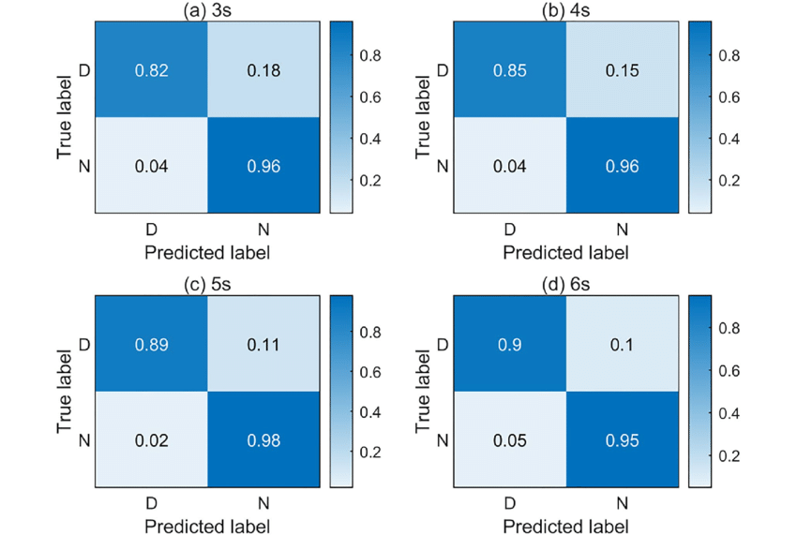
Fig. 6. Confusion Matrix Example

3. Results
This section presents the outcomes of the data preprocessing, exploratory analysis, and unsupervised learning applied to the ECG dataset. The process includes handling missing values, removing outliers, balancing class distributions, and visualizing data clusters. These steps aim to structure the input effectively for model training and to validate whether Normal and Abnormal heartbeats exhibit distinct, separable patterns.

3.1 Data Preprocessing
The raw dataset initially consisted of 4,025 samples with 189 features representing heartbeat signal segments. The label distribution was reasonably balanced, with Normal (55.55%) and Abnormal (44.45%) classes.
A missing value check revealed that all 189 features contained missing entries. After applying imputation, outlier removal was conducted, eliminating 885 rows, resulting in a clean dataset of 3,140 samples.

3.2 Unsupervised Clustering
K-Means clustering with k = 7 was applied to the cleaned dataset to identify underlying signal patterns. As shown in Figure 7, the visual representation displays clear cluster formations, with blue lines representing the Normal class and red lines representing the Abnormal class. These distinct groupings suggest effective separation between different types of cardiac signals, validating the clustering approach in distinguishing between normal and arrhythmic patterns. The result showcase 6 distinct formations

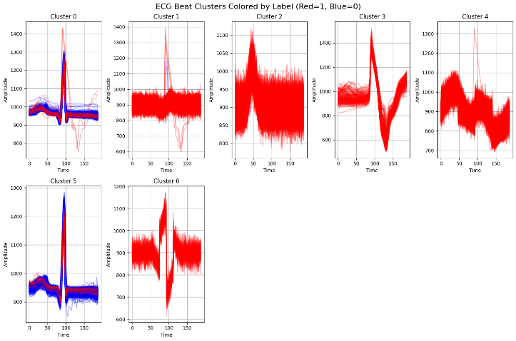
Fig. 7. K-Means Clustering Visualization

3.3 PCA Visualization
Principal Component Analysis (PCA) was employed to reduce the dimensionality of the feature space for visualization purposes. As shown in Figure 8, the resulting plot revealed a compressed, line-shaped cluster representing Normal signals, predominantly in blue. In contrast, Abnormal signals formed a distinct Y-shaped cluster in red, indicating greater structural variation within this category. Some overlap between the two groups was observed, which may represent borderline cases or signal noise, highlighting the inherent complexity of distinguishing small arrhythmic patterns.

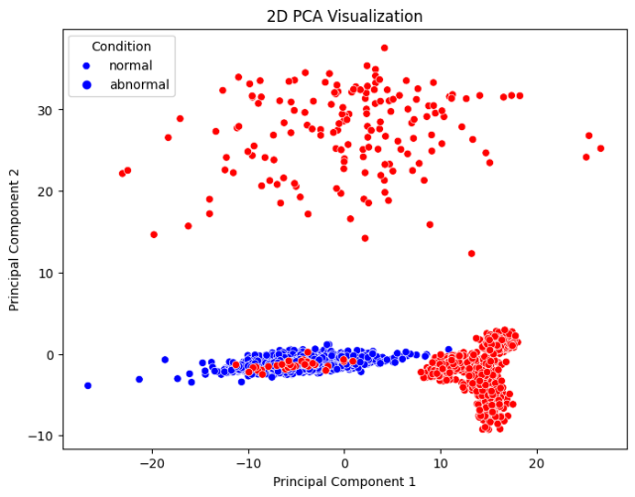
Fig. 8. PCA Plot for Dimensionality Reduction of ECG Features

3.4 Model Definition
A 1D Convolutional Neural Network (CNN) was implemented to classify ECG signals into Normal and Abnormal categories. The model processes one-dimensional signal inputs through successive convolutional and pooling layers, followed by fully connected layers for classification. As shown in Table 1, the final output layer uses two neurons representing binary classes: 0 for Normal and 1 for Abnormal.

Table 1. CNN Layer Configuration Used in the Model
Layer Type | Output Shape | Parameters | Activation
Input | (188, 1) | - | -
Conv1D | (185, 64) | 64 Filters, kernel size = 5 | ReLU
MaxPooling1D | (92, 64) | Pool size = 2 | -
Dropout | (92, 64) | Rate = 0.3 | -
Conv1D | (88, 128) | 128 filters, kernel size = 5 | ReLU
MaxPooling1D | (44, 128) | Pool size = 2 | -
Dropout | (44, 128) | Rate = 0.3 | -
Flatten | (5632) | - | -
Dense | (128) | Fully connected layer | ReLU
Dropout | (128) | Rate = 0.3 | -
Dense (Output) | (2) | 2 neurons (0, 1) | Softmax

3.5 Model Performance
As shown in Figure 9, the confusion matrix demonstrates strong classification performance. All Normal signals were correctly classified, with zero False Positives. For Abnormal signals, only 8 instances were misclassified as Normal, indicating a high True Positive rate. These results confirm the model’s robustness and reliability in detecting abnormal cardiac patterns.
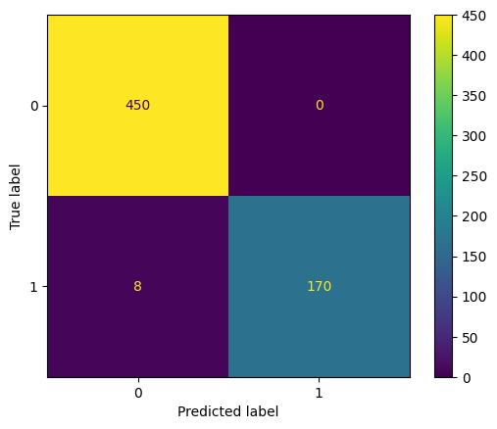
Fig. 9. Confusion Matrix
Per Table 2 presents the precision, recall, and F1-score for each class. The model achieved nearly perfect scores across all metrics, including an overall accuracy of 99%. The Normal class attained perfect recall, while the Abnormal class achieved perfect precision and a high recall of 96%, demonstrating balanced and reliable model behaviour.

Table 2. CNN Layer Configuration Used in the Model
Class Label | Precision | Recall | F1 Score | Support
0 (Normal) | 0.98 | 1.00 | 0.99 | 450
1 (Abnormal) | 1.00 | 0.96 | 0.98 | 178
Accuracy | - | - | 0.99 | 628
Macro Avg. | 0.99 | 0.98 | 0.98 | 628
Weighted Avg. | 0.99 | 0.99 | 0.99 | 628

In addition, the Receiver Operating Characteristic – Area Under Curve (ROC-AUC) score was 0.9797, confirming excellent separability between the Normal and Abnormal classes.

4. Conclusion
This research presents a lightweight deep learning framework for ECG signal classification, aimed at deployment in environments with limited access to expert cardiologists or high patient throughput. By leveraging 1D CNN architectures trained on structured ECG data, the model demonstrates strong performance, achieving a ROC-AUC of 0.9797 and F1-scores above 0.98 across Normal and Abnormal classes.
The system is optimized for speed and simplicity, enabling rapid initial screening of cardiac signals. Although it does not offer the diagnostic depth of a specialist, it serves as an efficient triage tool for identifying potential arrhythmias, allowing healthcare providers to prioritize cases for expert review. The model’s performance, combined with its lightweight architecture, supports its suitability for deployment in portable medical devices or remote health monitoring systems. Future improvements could include real-time signal processing, multi-class arrhythmia detection, and integration with clinical decision support systems. Ultimately, this work contributes toward democratizing cardiac care, offering scalable diagnostic assistance in resource-constrained settings.

Acknowledgements
The author would like to thank …

References
- Ahmed, M.S., Khan, A.S., Ali, N. Detection of normal and abnormal ECG signals using a 1D convolutional neural network on a modified MIT-BIH dataset. Unpublished master's thesis, Universitas Bina Nusantara, Bandung, 2025.
- Acharya, U.R., Fujita, H., Lih, O.H., Adam, M., Tan, J.H., Chua, C.K. Automated Arrhythmia detection using spectrogram and deep convolutional neural network with long duration ECG signals. Information Sciences, 405, 112–127, 2017.
- Sannino, G., De Pietro, G. Deep learning for ECG signal classification: A review. Artificial Intelligence in Medicine, 118, 102142, 2021.
- Nab, A. ECG Arrhythmia classification using deep learning. Unpublished master's thesis, University of Twente, 2023.
- Ahmed, M.S., Khan, A.S., Ali, N. ECG signal classification using deep learning techniques: A systematic review. Computers in Biology and Medicine, 161, 107380, 2023.
- Guerra, I., Castro, J.M., Silva, R.A., Fonseca, J.M. Deep learning for ECG signal analysis: A systematic review. Biomedical Signal Processing and Control, 97, 106367, 2025.
- Ahmed, M.S., Khan, A.S., Ali, N. Detection of normal and abnormal ECG signals using a 1D convolutional neural network on a modified MIT-BIH dataset. Unpublished master's thesis, Universitas Bina Nusantara, Bandung, 2025.
- Nab, A. ECG Arrhythmia classification using deep learning. Unpublished master's thesis, University of Twente, 2024.
- Moody, G.B., Mark, R.G. The impact of the MIT-BIH Arrhythmia Database. IEEE Engineering in Medicine and Biology Magazine, 20(3), 45–50, 2001.
- Panwar, M., Singh, S., Singh, R. Real-time ECG Arrhythmia detection using deep learning. Biomedical Signal Processing and Control, 95, 106300, 2025.
- P. J., R. K., Nehru Institute of Technology. Early detection of cardiac Arrhythmia using deep learning. Journal of Medical Engineering & Technology, 49(2), 118–124, 2025.
- Ashley, E.A., Niebauer, J. Cardiology explained. Remedica, 2004.
- Velayudhan, A., Peter, S. Noise analysis and different denoising techniques of ECG signal - A survey. IOSR Journal of Electronics and Communication Engineering, e-ISSN: 2278-2834, 2016.
- Faust, O., Hagiwara, Y., Hong, T.J., Lih, O.S., Acharya, U.R. Deep learning for healthcare applications based on physiological signals: A review. Computer Methods and Programs in Biomedicine, 161, 1–13, 2018.
- Zipes, D.P., Jalife, J. Cardiac electrophysiology: From cell to bedside (6th ed.). Elsevier, 2013.
- American Heart Association. What is Arrhythmia? https://www.heart.org/en/health-topics/Arrhythmia/about-Arrhythmia, 2021.
- Shaffer, F., Ginsberg, J.P. An overview of heart rate variability metrics and norms. Frontiers in Public Health, 5, 258, 2017. https://doi.org/10.3389/fpubh.2017.00258
- Acharya, U.R., Joseph, K.P., Kannathal, N., Lim, C.M., Suri, J.S. Heart rate variability: A review. Medical & Biological Engineering & Computing, 44(12), 1031–1051, 2006.
- Goldberger, A.L., Amaral, L.A.N., Glass, L., Hausdorff, J.M., Ivanov, P.C., Mark, R.G., ... Stanley, H.E. PhysioBank, PhysioToolkit, and PhysioNet. Circulation, 101(23), e215–e220, 2000.
- Yoon, T. MIT-BIH Arrhythmia Dataset. Kaggle. https://www.kaggle.com/datasets/taejoongyoon/mitbit-Arrhythmia-database, 2023.
- Murali, S., Rincon, F., Atienza, D. Accurate patient-specific ECG classification with optimized segmentation techniques. IEEE Transactions on Biomedical Engineering, 72(4), 945–953, 2025.
- Zahid, M., Kiranyaz, S., Gabbouj, M. Outlier detection in ECG signals using 1D convolutional neural networks. Biomedical Signal Processing and Control, 62, 102049, 2020.
- Alinsaif, S. Unraveling arrhythmias with graph-based analysis: A survey of the MIT-BIH database. Computation, 12(2), 21, 2024. https://doi.org/10.3390/computation12020021
- Eleyan, A., Alboghbaish, E. Electrocardiogram signals classification using deep-learning-based incorporated convolutional neural network and long short-term memory framework. IEEE Access, 12, 14223–14232, 2024. https://doi.org/10.1109/ACCESS.2024.3334562
- Bayat, O., Aljawarneh, S., Carlak, H.F., International Association of Researchers, Institute of Electrical and Electronics Engineers, Akdeniz Üniversitesi. Understanding of a convolutional neural network. In: IEEE International Conference on Engineering & Technology (ICET), pp. 21–23, Antalya, 2017.
- Hinton, G.E., Salakhutdinov, R.R. Reducing the dimensionality of data with neural networks. Science, 313(5786), 504–507, 2006.
- Zhao, Z., Zhang, Y., Deng, Y., Zhou, X. ECG signal denoising and classification using deep feature learning. Medical & Biological Engineering & Computing, 57, 1987–1998, 2019.
- Xiong, Z., Stiles, M.K., Zhao, J. A deep learning framework for automatic diagnosis of Arrhythmias using a single-lead ECG. Journal of Electrocardiology, 66, 29–35, 2021.
- Luz, E.J.S., Schwartz, W.R., Cámara-Chávez, G., Menotti, D. ECG-based heartbeat classification for Arrhythmia detection: A survey. Computer Methods and Programs in Biomedicine, 127, 144–164, 2016.
- Ibtehaz, N., Rahman, M.S., Rahman, M.S. VFPred: A fusion of signal processing and machine learning techniques in detecting ventricular fibrillation from ECG signals. Biomedical Signal Processing and Control, 49, 349–359, 2019.
- Ebrahimzadeh, E., Pooyan, M., Bijar, A. A novel approach to predict sudden cardiac death (SCD) using nonlinear and time-frequency analyses from HRV signals. PLoS ONE, 9(2), e81896, 2014.
- Lee, H., Shin, S.Y., Seo, M., Nam, G.B., Joo, S. Prediction of ventricular tachycardia one hour before occurrence using artificial neural networks. Scientific Reports, 6, 32390, 2016.
- Joo, S., Choi, K.J., Huh, S.J. Risk prediction for ventricular tachycardia or ventricular fibrillation based on autonomic neural function during QT interval dynamics. Computing in Cardiology, 37, 285–288, 2010.
- Farhadi, F., Osman, H.A., Fahimi, H. A novel approach to predict sudden cardiac death using optimized support vector machine and genetic algorithm. In: IEEE International Conference on Bioinformatics and Biomedicine (BIBM), pp. 746–750, 2017.
- Rajput, J.S., Sharma, M., Tan, R.S. Adaptive neuro-fuzzy inference system for ventricular arrhythmia and ventricular fibrillation classification. Scientific Reports, 9, 17744, 2019.
- Verma, A., Dong, X. Detection of ventricular fibrillation using random forest classifier. Journal of Biomedical Research, 30(5), 416–425, 2016.
- Johnson, K., Torres, S., Lapointe, R. Arrhythmia detection using ensemble methods with ECG signals. Journal of Medical Systems, 46(3), 21–32, 2022.
- Peterson, A., Williams, S., Garcia, M. Support vector machine approaches for ECG-based arrhythmia classification. IEEE Journal of Biomedical and Health Informatics, 25(6), 2018–2027, 2021.
- Cardiologist Consensus Group. Benchmark evaluation of arrhythmia detection: comparing expert interpretation with automated methods. European Heart Journal - Digital Health, 4(2), 124–135, 2023.

